Aim: To remember the important tasks and forget the less important tasks using LSTM
IDE: Google Collab

Theory:
Countless learning tasks require dealing with sequential data. Image captioning, speech synthesis, and music generation all require that models produce outputs consisting of sequences. In other domains, such as time series prediction, video analysis, and musical information retrieval, a model must learn from inputs that are sequences. These demands often arise simultaneously: tasks such as translating passages of text from one natural language to another, engaging in dialogue, or controlling a robot, demand that models both ingest and output sequentially- structured data.
Recurrent neural networks (RNNs) are deep learning models that capture the dynamics of sequences via recurrent connections, which can be thought of as cycles in the network of nodes. This might seem counterintuitive at first. After all, it is the feedforward nature of neural networks that makes the order of computation unambiguous. However, recurrent edges are defined in a precise way that ensures that no such ambiguity can arise. Recurrent neural networks are unrolled across time steps (or sequence steps), with the same underlying parameters applied at each step. While the standard connections are applied synchronously to propagate each layer’s activations to the subsequent layer at the same time step, the recurrent connections are dynamic, passing information across adjacent time steps. As the unfolded view reveals, RNNs can be thought of as feedforward neural networks where each layer’s parameters (both conventional and recurrent) are shared across time steps. Like neural networks more broadly, RNNs have a long discipline-spanning history, originating as models of the brain popularized by cognitive scientists and subsequently adopted as practical modeling tools employed by the machine learning community.
The name of LSTM refers to the analogy that a standard RNN has both "long-term memory" and "short-term memory". The connection weights and biases in the network change once per episode of training, analogous to how physiological changes in synaptic strengths store long-term memories; the activation patterns in the network change once per time-step, analogous to how the moment-to-moment change in electric firing patterns in the brain store short-term memories. The LSTM architecture aims to provide a short-term memory for RNN that can last thousands of timesteps, thus "long short-term memory".
A common LSTM unit is composed of a cell, an input gate, an output gate, and a forget gate. The cell remembers values over arbitrary time intervals, and the three gates regulate the flow of information into and out of the cell. LSTM networks are well-suited to classifying, processing, and making predictions based on time series data, since there can be lags of unknown duration between important events in a time series. LSTMs were developed to deal with the vanishing gradient problem that can be encountered when training traditional RNNs. Relative

insensitivity to gap length is an advantage of LSTM over RNNs, hidden Markov models, and other sequence learning methods in numerous applications.

Methodology:
- Load the basic libraries and packages
- Load the dataset
- Analyze the dataset
- Apply LSTM Model
- Apply the training to the dataset to minimize the loss
- Observe the cost function vs iterations learning curve

Program (Code):
# Import Libraries
import nltk
from nltk.util import ngrams
from collections import defaultdict, Counter
import random

nltk.download('punkt')
nltk.download('punkt_tab')

# Sample Corpus
corpus = """
I like machine learning
I like deep learning
I enjoy machine learning
I enjoy data science
Machine learning is interesting
Deep learning is powerful
"""

# Tokenize
tokens = nltk.word_tokenize(corpus.lower())

# Create Bigram Model
n = 2
model = defaultdict(Counter)

for w1, w2 in ngrams(tokens, n):
model[w1][w2] += 1

# Convert counts to probabilities
for w1 in model:
total_count = float(sum(model[w1].values()))
for w2 in model[w1]:
model[w1][w2] /= total_count

# Function to Predict Next Word
def predict_next_word(word):
if word in model:
return max(model[word], key=model[word].get)
else:
return "No prediction available"

# Test Predictions
print("Next word after 'machine':", predict_next_word("machine"))
print("Next word after 'deep':", predict_next_word("deep"))
print("Next word after 'learning':", predict_next_word("learning"))

Results:
- Model Summary
- Training and Validation accuracy v/s epochs
- Training and Validation loss v/s epochs
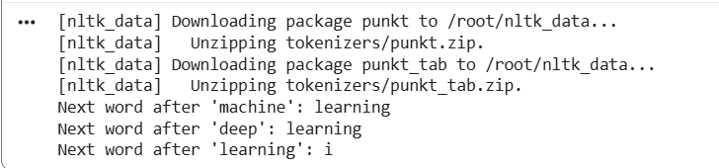

Observation and Result Analysis:
- Nature of the dataset
- During the training process

- After the training Process
- Observation over the Learning Curve

Post Lab Exercise:
- What is the requirement of LSTM over RNN?
RNN suffers from the vanishing gradient problem
Cannot remember long-term dependencies
LSTM solves this using: Forget gate, Input gate, and Output gate.
Hence, LSTM is better for long sequences
- Interpretation of the graph
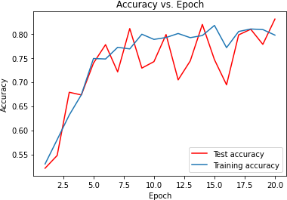
- X-axis: Epochs
- Y-axis: Loss
- Decreasing curve: model is learning
- Flat curve: convergence
- Increasing validation loss: overfitting

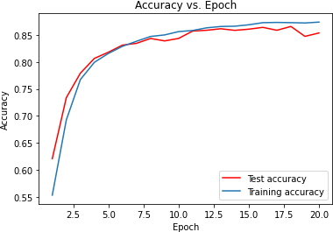

What is the meaning of the above graph? How can the graph be smoothed?
Meaning:
- Shows how well the model is learning over time
To smooth the graph:
- Increase dataset size
- Use batch normalization
- Reduce learning rate
- Use dropout
- Train for more epochs

Post Lab Activity
Obtain the prediction value of the TCS stock for the historical data obtained from the link mentioned as: https://in.investing.com/equities/tata-consultancy-services-historical-data

Select the Date Range from (01-01-2020 to 31-03-2024). Select the price range to be as “DAILY” stock values. Train your LSTM model to obtain the predicted value as close to the actual value. Paste the screenshot of the output.
Code:
# Install required library
!pip install yfinance

# Import libraries
import numpy as np
import pandas as pd
import matplotlib.pyplot as plt
import yfinance as yf

from sklearn.preprocessing import MinMaxScaler
from tensorflow.keras.models import Sequential
from tensorflow.keras.layers import Dense, LSTM

# Load TCS stock data
data = yf.download("TCS.NS", start="2020-01-01", end="2024-03-31")
data = data[['Close']]

# Normalize data
scaler = MinMaxScaler(feature_range=(0,1))
scaled_data = scaler.fit_transform(data)

# Create sequences
X, y = [], []
time_step = 60

for i in range(time_step, len(scaled_data)):
X.append(scaled_data[i-time_step:i, 0])
y.append(scaled_data[i, 0])

X, y = np.array(X), np.array(y)

# Reshape for LSTM
X = X.reshape(X.shape[0], X.shape[1], 1)

# Train-test split
split = int(0.8 * len(X))
X_train, X_test = X[:split], X[split:]
y_train, y_test = y[:split], y[split:]

# Build LSTM model
model = Sequential()
model.add(LSTM(50, return_sequences=True, input_shape=(X.shape[1],1)))
model.add(LSTM(50))
model.add(Dense(1))

model.compile(optimizer='adam', loss='mean_squared_error')

# Train model
history = model.fit(X_train, y_train, epochs=20, batch_size=32,
validation_data=(X_test, y_test))

# Plot Loss Graph
plt.figure()
plt.plot(history.history['loss'], label='Training Loss')
plt.plot(history.history['val_loss'], label='Validation Loss')
plt.legend()
plt.title("Loss vs Epochs")
plt.show()

# Predictions
predictions = model.predict(X_test)

# Convert back to original scale
predictions = scaler.inverse_transform(predictions.reshape(-1,1))
y_test_actual = scaler.inverse_transform(y_test.reshape(-1,1))

# Plot Actual vs Predicted
plt.figure()
plt.plot(y_test_actual, label='Actual Price')
plt.plot(predictions, label='Predicted Price')
plt.legend()
plt.title("TCS Stock Price Prediction")
plt.show()
Output:
